Activity Diagram

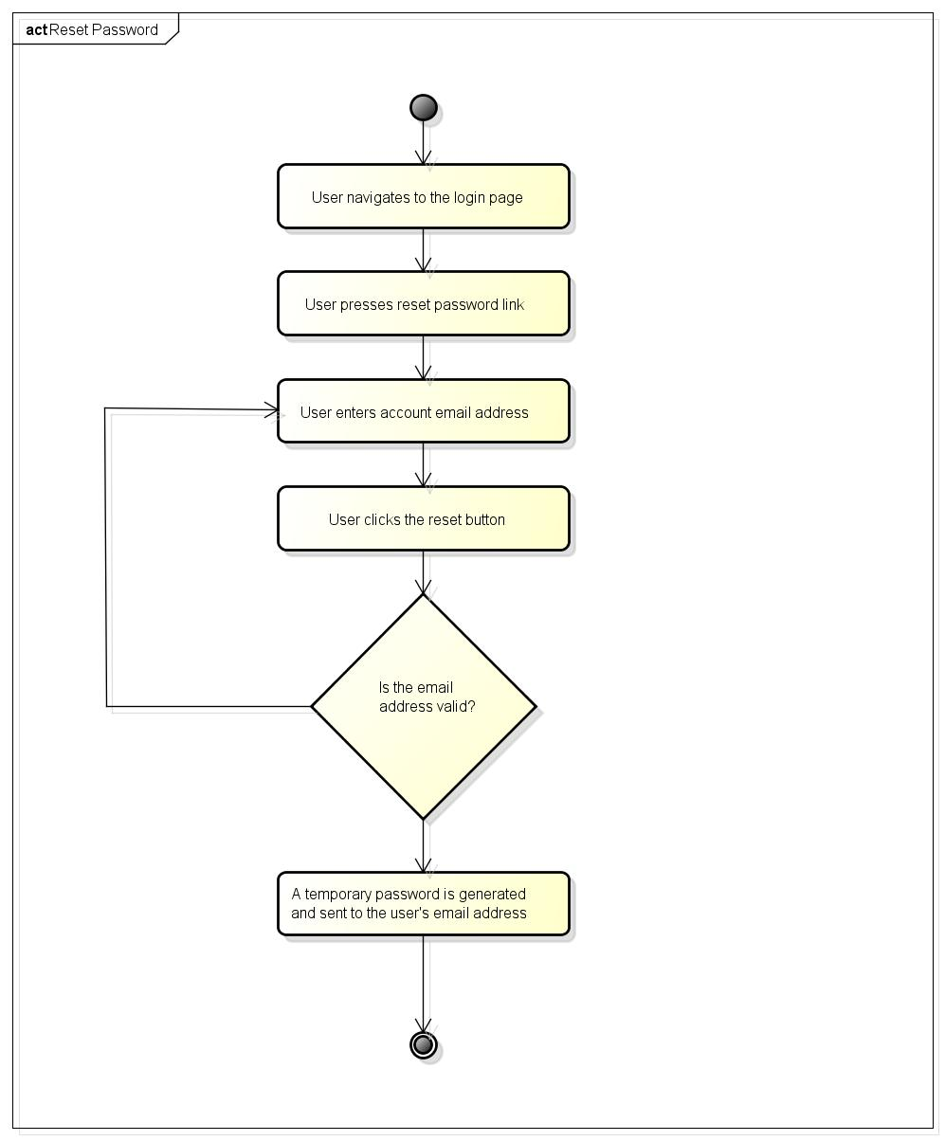

Figure 1: Figure 1